KAUNO TECHNOLOGIJOS UNIVERSITETAS

INFORMATIKOS FAKULTETAS

Programavimo kalbų teorija (P175B124)

Laboratorinių darbų ataskaita

Atliko:

IFF – 6/8 gr. studentas

Tadas Laurinaitis

2019 m. vasario 17 d.

Priėmė:

Lekt. Evaldas Guogis

KAUNAS 2019

TURINYS

1. Python arba Ruby (L1) 3

1.1. Darbo užduotis 3

1.2. Programos tekstas 3

1.3. Pradiniai duomenys ir rezultatai 4

2. Scala (L2) 4

3. Haskell (L3) 4

4. Prolog (L4) 4

#### 1.1 Darbo užduotis

Pav #1 Darbo užduotis

#### 1.2 Programos tekstas

#Number class used to store a number and a number which shows a cumulative sum of each numbers divisors from 1 to number

class Number:

def __init__(self, number, cumulativeSum):

self.number = number

self.cumulativeSum = cumulativeSum

def get_number(self):

return self.number

#finds sum of all viable divisors of number n

def findSumOfDivisors(n):

sum = 0

for x in range(2, int(n)):

z = n / x #temporary result of division

if z == int(z):

sum = sum + z

return sum

#finds cumulative sum of divisors for numbers 1 to Number.number

def findCumulativeSumOfDivisors(Number):

for x in range(0, Number.number + 1):

Number.cumulativeSum = Number.cumulativeSum + findSumOfDivisors(x)

print("Cumulative sum of divisors of number n: " + str(Number.number) + " is: " + str(Number.cumulativeSum))

return Number

#reads data from file into integer array

def readIntoArray(fileName):

array = []

with open('data.txt') as f:

for line in f: # read all lines

array.append(int(line))

return array

#finds results for all integers in array

def findResults(array):

numberArray = []

for x in array:

temp = Number(x, 0)

temp = findCumulativeSumOfDivisors(temp)

numberArray.append(temp)

array = readIntoArray("data.txt")

findResults(array)

#### 1.3 Pradiniai duomenys ir rezultatai

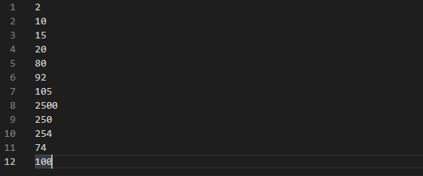

Pav #2 Duomenų failas

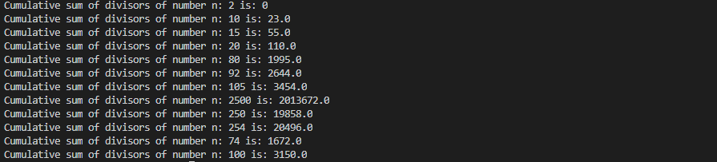

Pav #3 Gauti rezultatai